ADDITIONAL QUESTIONS

1]
#include<stdio.h>
#include<stdlib.h>
struct Node{
int data;
struct Node* next;
};
struct Node* head = NULL;
// Helper to insert at end
void insertEnd(int x){
struct Node* newNode = malloc(sizeof(struct Node));
newNode->data = x;
newNode->next = NULL;
if (head == NULL){
head = newNode;
} else {
struct Node* t = head;
while (t->next) t = t->next;
t->next = newNode;
}
}
// Helper to display list
void display(struct Node* h){
struct Node* t = h;
while (t) {
printf("%d -> ", t->data);
t = t->next;
}
printf("NULL\n");
}
// Reverse between position L and R (1-indexed)
struct Node* reverseBetween(struct Node* head, int L, int R){
if (head == NULL || L == R) return head;
struct Node dummy;
dummy.next = head;
struct Node* prev = &dummy;
// Move prev to node just before L
for (int i = 1; i < L; i++) {
if (prev->next == NULL) break;
prev = prev->next;
}
struct Node* curr = prev->next;
struct Node* next;
// Reverse the sublist
for (int i = 0; i < R - L; i++){
if (curr == NULL || curr->next == NULL) break;
next = curr->next;
curr->next = next->next;
next->next = prev->next;
prev->next = next;
}
return dummy.next;
}
int main(){
int n, x, L, R;
printf("Enter number of nodes: ");
scanf("%d", &n);
printf("Enter list values:\n");
for (int i = 0; i < n; i++) {
scanf("%d", &x);
insertEnd(x);
}
printf("Original list:\n");
display(head);
printf("Enter L and R: ");
scanf("%d %d", &L, &R);
head = reverseBetween(head, L, R);
printf("List after reversing between %d and %d:\n", L, R);
display(head);
return 0;
}
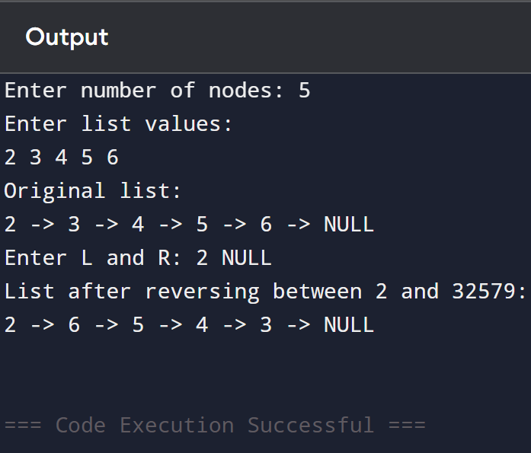

2]
#include<stdio.h>
#include<stdlib.h>
struct Node{
int data;
struct Node* next;
};
struct Node* head = NULL;
void insertEnd(int x){
struct Node* newNode = malloc(sizeof(struct Node));
newNode->data = x;
newNode->next = NULL;
if (head == NULL){
head = newNode;
} else {
struct Node* t = head;
while (t->next) t = t->next;
t->next = newNode;
}
}
void display(struct Node* h){
struct Node* t = h;
while (t){
printf("%d -> ", t->data);
t = t->next;
}
printf("NULL\n");
}
// Rotate the list to the right by k places
struct Node* rotateRight(struct Node* head, int k){
if (head == NULL || k == 0) return head;
// compute length and tail
struct Node* tail = head;
int len = 1;
while (tail->next) {
tail = tail->next;
len++;
}
// make circular
tail->next = head;
// effective rotations
k = k % len;
int steps = len - k;
struct Node* newTail = tail;
while (steps--){
newTail = newTail->next;
}
struct Node* newHead = newTail->next;
newTail->next = NULL;
return newHead;
}
int main(){
int n, x, k;
printf("Enter number of nodes: ");
scanf("%d", &n);
printf("Enter list values:\n");
for (int i = 0; i < n; i++) {
scanf("%d", &x);
insertEnd(x);
}
printf("Original list:\n");
display(head);
printf("Enter k: ");
scanf("%d", &k);
head = rotateRight(head, k);
printf("List after rotating by %d:\n", k);
display(head);
return 0;
}
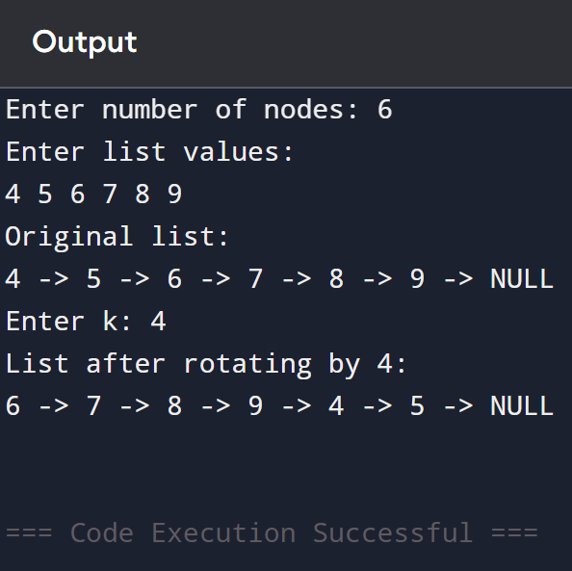

3]
#include<stdio.h>
#include<stdlib.h>
struct Poly{
int coeff;
int pow;
struct Poly* next;
};
// Make new node
struct Poly* newTerm(int c, int p){
struct Poly* node = malloc(sizeof(struct Poly));
node->coeff = c;
node->pow = p;
node->next = NULL;
return node;
}
// Append term at end
void appendTerm(struct Poly** head, int c, int p){
struct Poly* node = newTerm(c, p);
if (*head == NULL){
*head = node;
} else {
struct Poly* t = *head;
while (t->next)
t = t->next;
t->next = node;
}
}
// Add two polynomials
struct Poly* addPoly(struct Poly* p1, struct Poly* p2){
struct Poly dummy;
struct Poly* tail = &dummy;
dummy.next = NULL;
while (p1 && p2){
if (p1->pow > p2->pow){
tail->next = newTerm(p1->coeff, p1->pow);
p1 = p1->next;
} else if (p1->pow < p2->pow){
tail->next = newTerm(p2->coeff, p2->pow);
p2 = p2->next;
} else {
// same power
int sum = p1->coeff + p2->coeff;
if (sum != 0)
tail->next = newTerm(sum, p1->pow);
p1 = p1->next;
p2 = p2->next;
}
tail = tail->next;
}
// leftover
while (p1){
tail->next = newTerm(p1->coeff, p1->pow);
tail = tail->next;
p1 = p1->next;
}
while (p2){
tail->next = newTerm(p2->coeff, p2->pow);
tail = tail->next;
p2 = p2->next;
}
return dummy.next;
}
// Print polynomial
void printPoly(struct Poly* poly){
struct Poly* t = poly;
while (t) {
printf("%dx^%d", t->coeff, t->pow);
if (t->next)
printf(" + ");
t = t->next;
}
printf("\n");
}
int main(){
struct Poly* p1 = NULL;
struct Poly* p2 = NULL;
int n1, n2, c, p;
printf("Enter number of terms for first polynomial: ");
scanf("%d", &n1);
printf("Enter coeff and power for each term:\n");
for (int i = 0; i < n1; i++) {
scanf("%d %d", &c, &p);
appendTerm(&p1, c, p);
}
printf("Enter number of terms for second polynomial: ");
scanf("%d", &n2);
printf("Enter coeff and power for each term:\n");
for (int i = 0; i < n2; i++) {
scanf("%d %d", &c, &p);
appendTerm(&p2, c, p);
}
printf("Polynomial 1: ");
printPoly(p1);
printf("Polynomial 2: ");
printPoly(p2);
struct Poly* sum = addPoly(p1, p2);
printf("Sum: ");
printPoly(sum);
return 0;
}
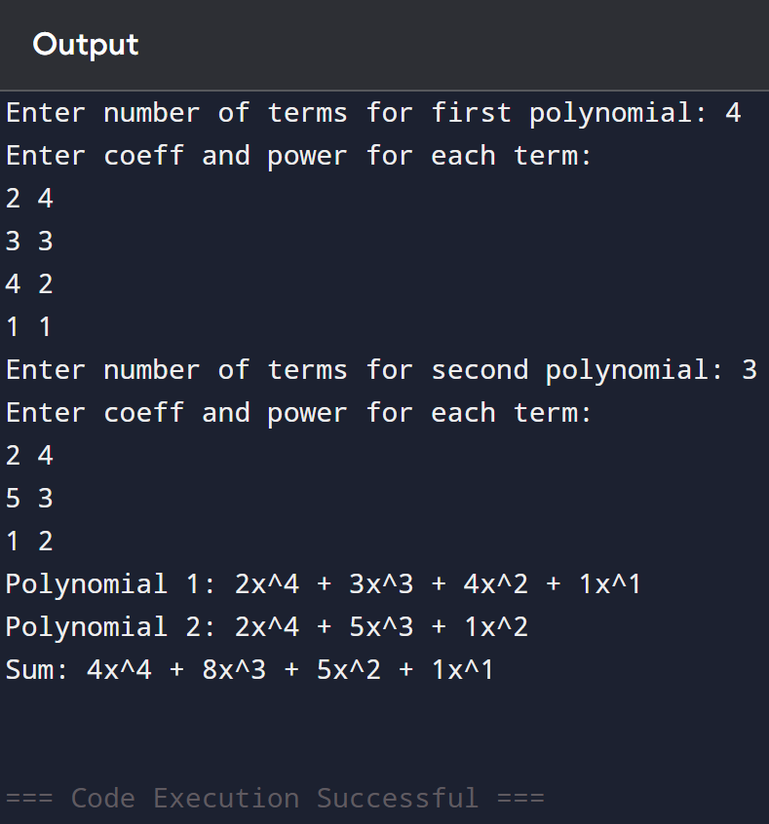

4]
#include<stdio.h>
#include<stdlib.h>
struct Node{
int data;
struct Node* next;
};
// Create a new node
struct Node* newNode(int d){
struct Node* node = malloc(sizeof(struct Node));
node->data = d;
node->next = NULL;
return node;
}
// Count nodes in a list
int getCount(struct Node* head){
int c = 0;
struct Node* curr = head;
while (curr){
c++;
curr = curr->next;
}
return c;
}
// Get intersection point when list1 is longer by d nodes
struct Node* _getIntersection(int d, struct Node* head1, struct Node* head2) {
struct Node* curr1 = head1;
struct Node* curr2 = head2;
// Move curr1 by d
for (int i = 0; i < d; i++){
if (curr1 == NULL) return NULL;
curr1 = curr1->next;
}
// Move both till they meet
while (curr1 && curr2){
if (curr1 == curr2)
return curr1;
curr1 = curr1->next;
curr2 = curr2->next;
}
return NULL;
}
// Get intersection node
struct Node* getIntersectionNode(struct Node* head1, struct Node* head2){
int c1 = getCount(head1);
int c2 = getCount(head2);
if (c1 > c2){
return _getIntersection(c1 - c2, head1, head2);
} else {
return _getIntersection(c2 - c1, head2, head1);
}
}
int main(){
// Example setup:
// List1: 3->6->9->15->30
// List2: 10->15->30 (intersection at 15)
struct Node* head1 = newNode(3);
head1->next = newNode(6);
head1->next->next = newNode(9);
head1->next->next->next = newNode(15);
head1->next->next->next->next = newNode(30);
struct Node* head2 = newNode(10);
head2->next = head1->next->next->next; // point to 15 in list1
struct Node* inter = getIntersectionNode(head1, head2);
if (inter)
printf("Intersection at node with data = %d\n", inter->data);
else
printf("No intersection\n");
return 0;
}
